**EXPERIMENT:20**

**Create a SQL storage service and perform a basic query using any Public Cloud Service Provider (Azure/GCP/AWS) to demonstrate Database as a Service (DaaS).**

STEP:1: CRAETE A SQL DATA BASE SERVER.

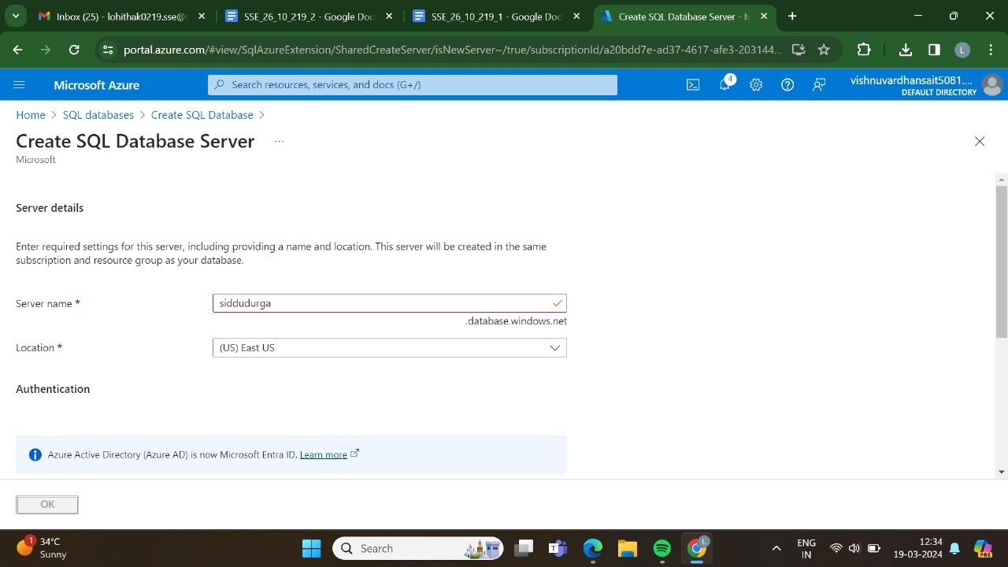

STEP 2: AND,THEN GO FOR THE BASICS.

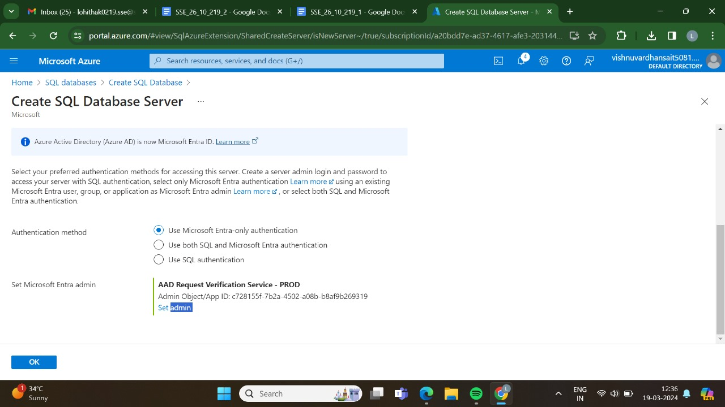

STEP 3: AND, THEN GO FOR THE NETWORKING.

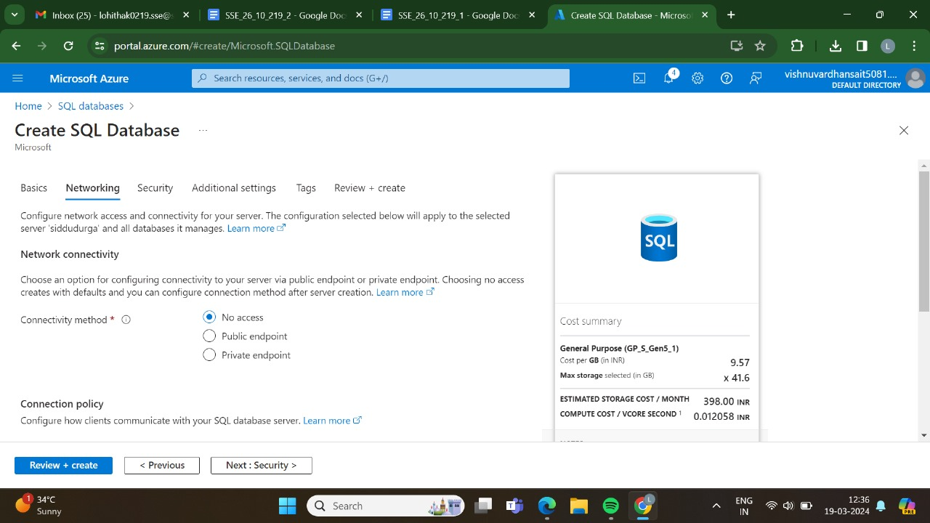

STEP 4: AND,THEN GO FOR THE SECURITY.

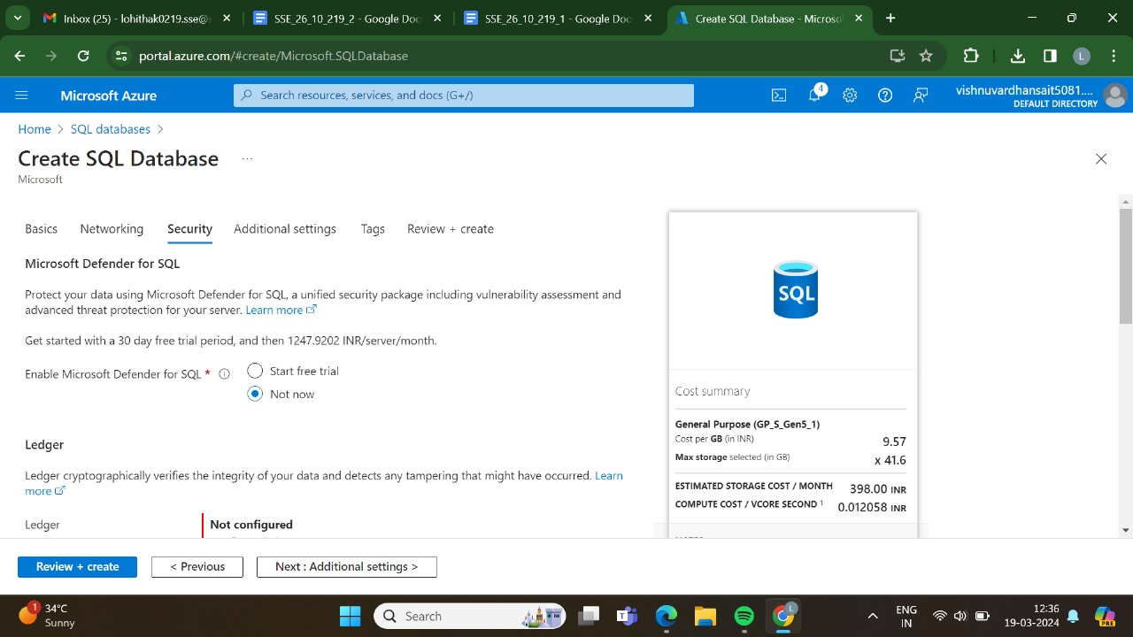

STEP 5: AND,THEN GO FOR THE ATTIDIONAL SETTINGS.

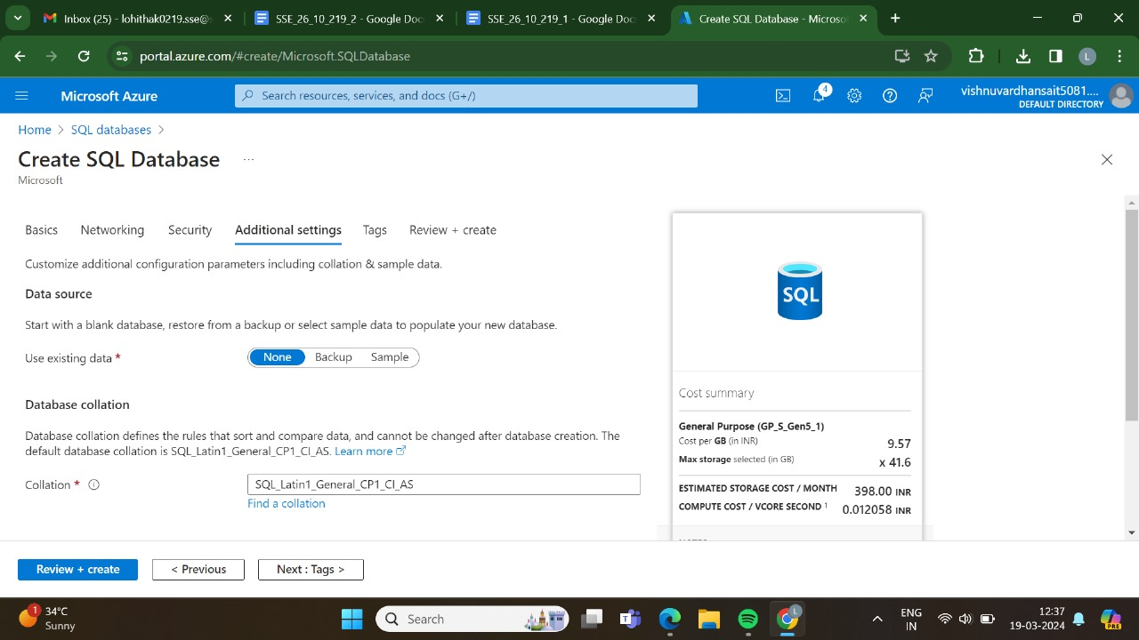

STEP 6: AND,THEN GO FOR THE TAGS.

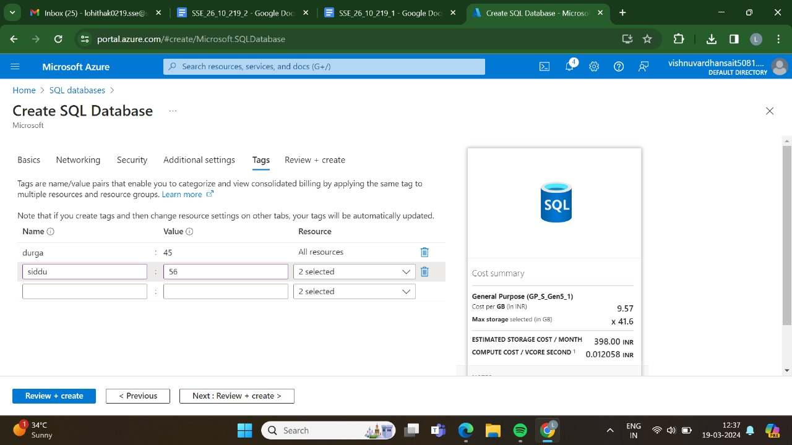

STEP 7:AND, THEN GO FOR THE REVIEW +CRAETE AND CLICK CREATE.

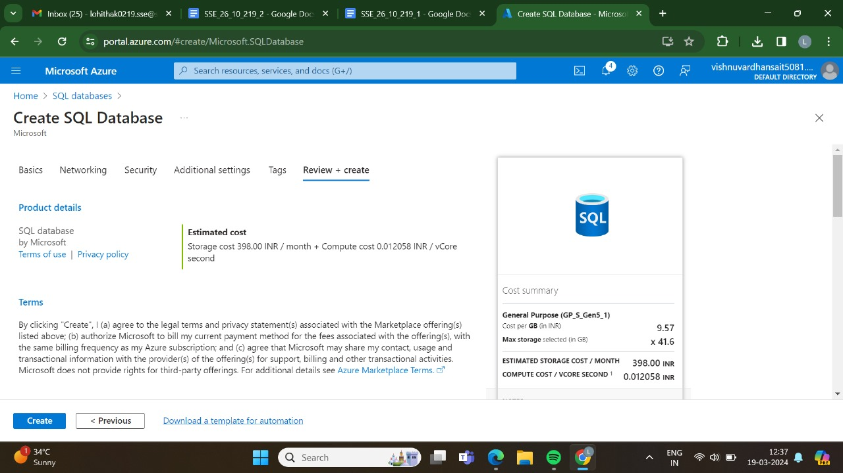

STEP 8: AND THEN GO FOR THE CREATE.



STEP 9:DEPLOYMENT IS IN PROGRESS.

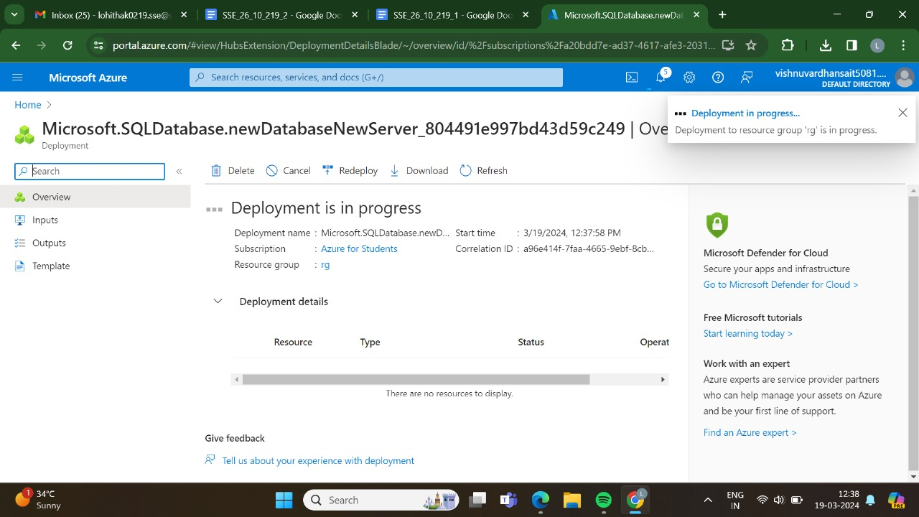

STEP 10: THE DEPLOYMENT HAS BEEN DONE SUCCESSFULLY.

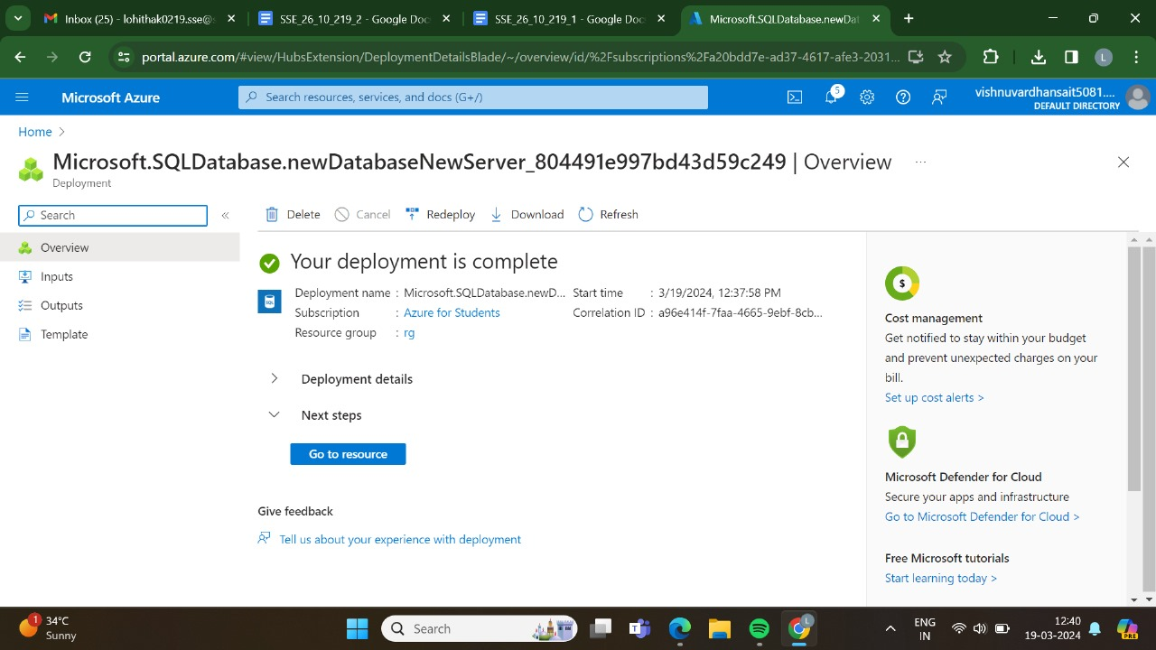

STEP 11: HERE,IS THE OUTPUT FOR THE SQL DATABASE SERVER.

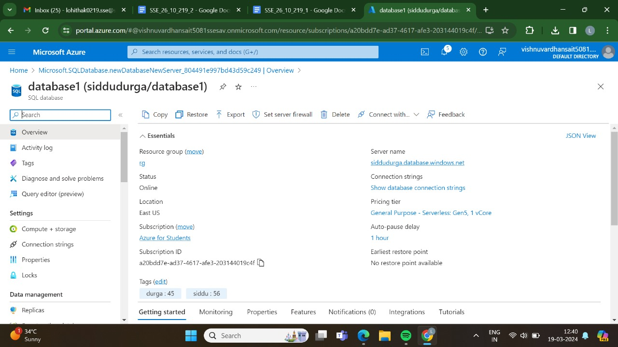

RESULT:THUS,THE PROGRAM HAS BEEN EXCEUTED SUCCESSFULLY.